Employee Management App

1. Initial Menu

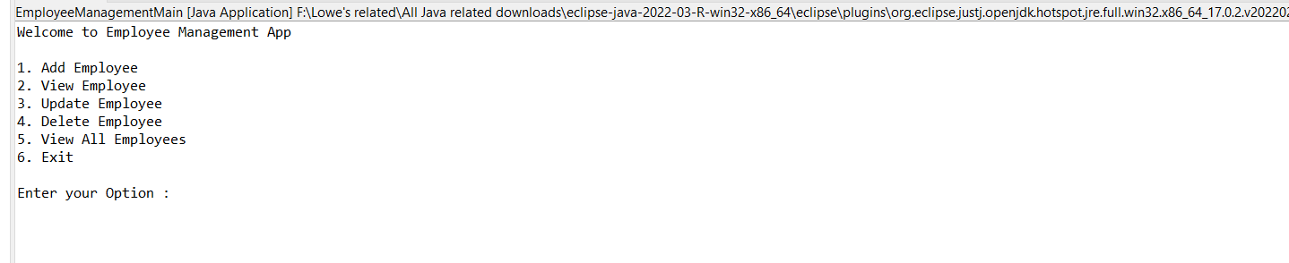

1. Initial View All when no records are available

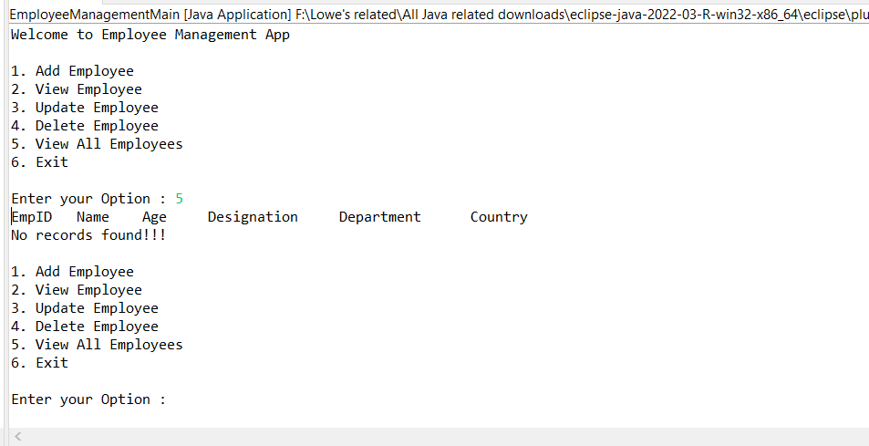

1. Add Employee option

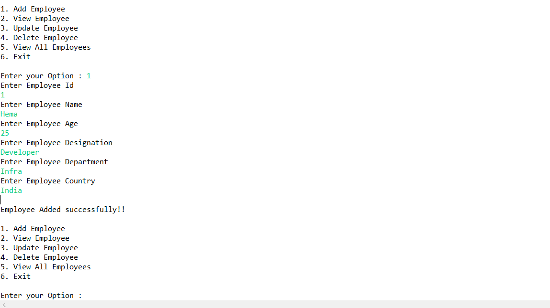

1. View after adding an employee

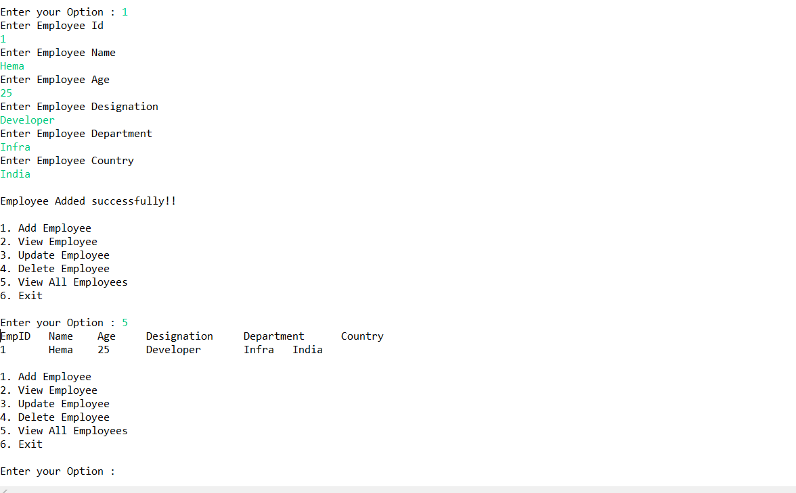

1. After adding another employee and view option showing 2 records

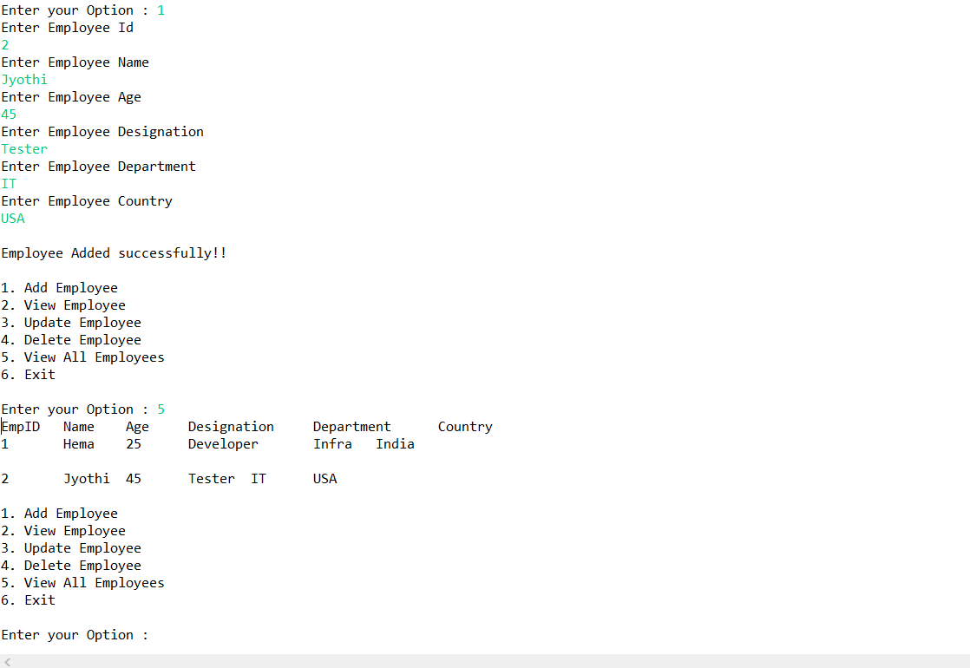

1. Update an employee(with existing Id)

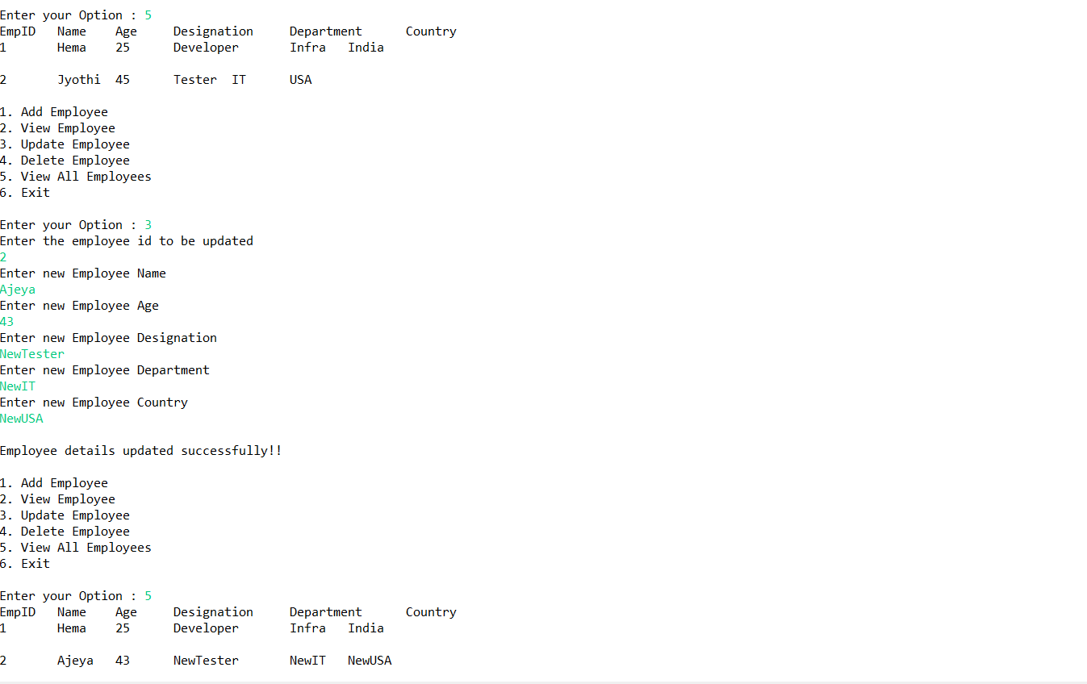

1. View by the existing Id and without existing Id

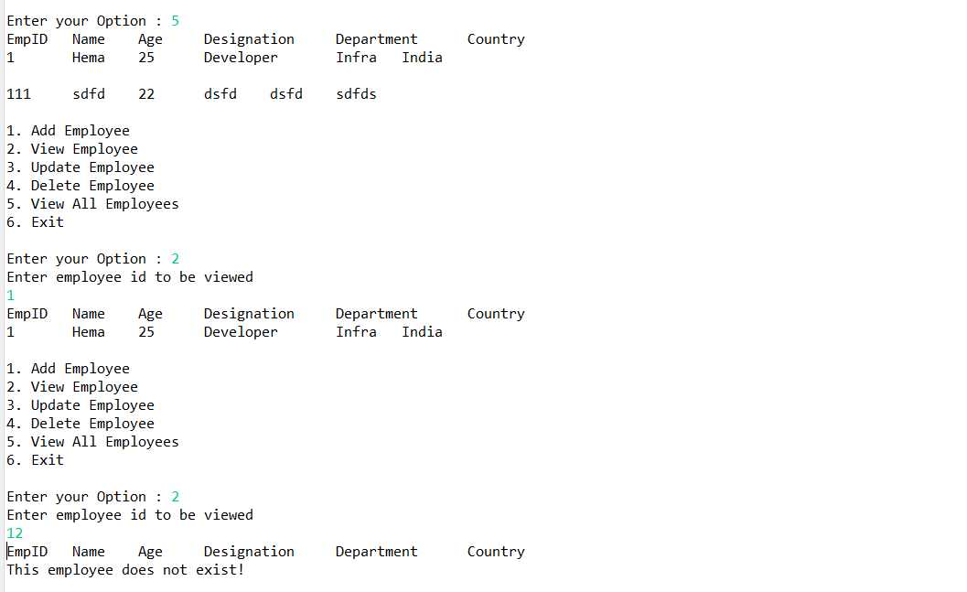

1. Delete an employee by giving non existing n existing id

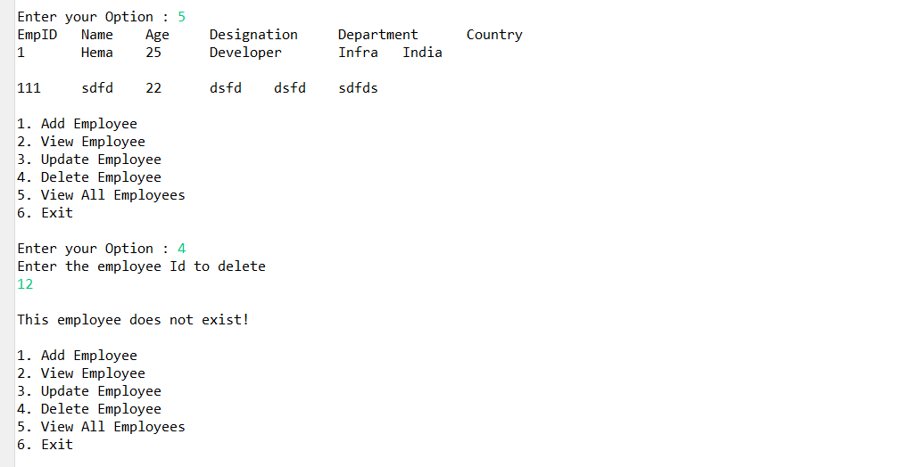

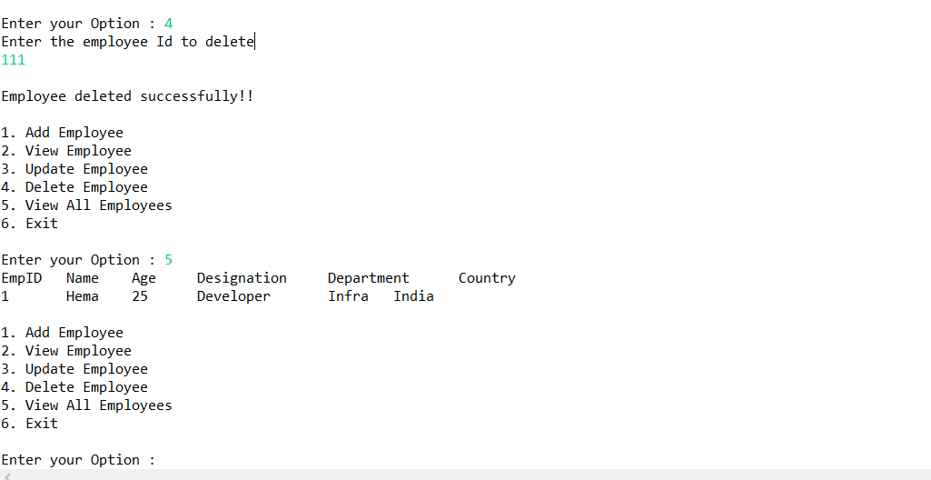

1. Exit option

